04.06.2018



**MIDDLE EAST TECHNICAL UNIVERSITY**

DEPARTMENT OF ELECTRICAL AND ELECTRONICS ENGINEERING

**EE 564** Project #3

***WIND TURBINE GENERATOR DESIGN***

GÖKHAN ÇAKAL – **2332120**

Contents

1. Introduction 2

2. Analytical Design 3

2.1. Main Dimensions 4

2.2. Stator Design 5

2.3. Stator Winding Design 7

2.4. Resistance and Efficiency 10

2.5. Mass Calculations 12

3. Finite Element Analysis 13

3.1 Performance Curves 13

3.2. Performance Data 15

3.3. Current and Voltage Waveforms 17

3.4. Flux Density Distribution 19

3.5. Effect of Rotor Slot Number 21

3.6. Comparison of Analytical and RMxpt Results 22

4. Conclusion 23

# Introduction

Renewable energy sources will have importance in our future. Wind energy is a type of renewable energy and today most of developed countries are building wind turbines. We see different types of generators are used in this wind turbines as generator. In this report, an induction generator for wind turbine application will be studied. This will be a squirrel cage induction generator with shorted bars in the rotor. The specifications of the wind turbine are as follows.

Table 1: Wind turbine specifications

|  |  |
| --- | --- |
| Property | Value |
| Rated power | 250 kW |
| Number of poles | 8 |
| Line to line voltage | 400 V |
| Frequency | 50 Hz |
| Rated speed | 758 rpm |
| Insulation class | F |

With the following specifications above, in the first part of the report, an analytical design will be created with pen and paper. Main generator dimensions, flux densities, loadings or other generator parameters will be studied in this first part.

In the second part of the report, finite element analysis will be conducted on RMxprt tool of Ansys Maxwell. Here, generator characteristics will be analyzed such as torque speed characteristics, power factor or efficiency. Comparison of analytical and simulation results will be presented in details.

# Analytical Design

In this part, analytical design of the generator will be studied. First of all, to simplify design procedure, we will consider our generator working as motor with the same slip, but positive slip. To make clear this, let’s consider following torque speed characteristics of an induction motor.



Figure 1: Torque speed characteristics

In above figure, we see desired torque speed characteristics of our induction motor. As generator, induction motor will work in B point as generator as wind turbine. Here, generator supplies power to grid. In A point, our machine works as motor. The two operation points have the same slip; with different signs. Since they have the same slip, we can consider our design problem as follows: induction machine will work as motor at 742 rpm. All other parameters will be the same. With this assumption, we can continue easier in design process. Nothing will differ.

To give information, squirrel cage rotors does not create an induced emf at armature terminals itself because no excitation is placed in the rotor. In the rotor, we have shorted conductor bars and there is nothing that can create MMF in the air gap. To work as generator, our induction machine should connect to the voltage source such as grid, and then our machine can work as generator if required external mover is supplied. Therefore, in following part of the report, we will consider our design problem as **motor design with rated speed of 742 rpm.**

## 2.1. Main Dimensions

In this first part, we will determine bore diameter, axial length of the motor, and air gap distance. To start with main motor dimensions, we should first determine some motor parameters such as electrical and magnetic loading. Magnetic loading represents average air gap flux density and it is safe to have magnetic loading of **0.45 – 0. 6 T for induction motors**. Electrical loading represents rms ampere turns per unit length of the air gap and it is safe to have **30 – 65 kA/m for induction machines**. We will proceed with following loadings.

Table 2: Loadings of machine

|  |  |
| --- | --- |
| Property | Value |
| Magnetic loading | 0.5 T |
| Electrical loading | 49 kA/m |

Secondly, we will define aspect ratio of our machine. It is defined as ratio of axial length to bore diameter in any machine. It has following relation as a rule of thumb.

Where is the effective axial length of motor, is bore diameter, and is pole number and it is 8. With this equation, we get a relation between bore diameter and axial length. We need another one and we will proceed with tangential stress of the motor. Here, we will use torque relation as follows.

Where is generated torque, is the tangential stress, is the rotor volume and and are peak values of electrical and magnetic loadings respectively, and lastly is the power factor. Here, we can write rotor volume in terms of bore diameter and aspect ratio. At the end, solving these two equations, we get following dimensions.

Lastly, air gap distance will be determined. Air gap distance is an important parameter of the motor. It is determined by production clearances. As a rule of thumb, it should be larger than 0.3 mm. With the increasing size of the machine, air gap clearance also increases. As air gap becomes smaller, reluctance decreases and inductance increases as a result. This leads higher power factor and better utilization of the motor. However, mechanical constraints limit this. As a rule of thumb, following relation can be used.

Where is the power of the machine. To make it straight, let’s choose **air gap distance as 1 mm.**

## Stator Design

In this part, stator parameters will be determined such as stator slot number, tooth width, and stator yoke height. First of all, let’s determine stator number of slots. While determining stator slot number, parameter that we should focus on should be slot pitch. Slot pitch is defined as axial distance between stator tooth in mm. For asynchronous machines, it is suitable to have **slot pitch of 7-45 mm**. For large machines, large slot pitch is defined. Stator main dimensions and slot dimensions are shown in following figure.



Figure 2: Stator dimensions

Now, let’s assume number of slots per pole per phase, is equal to 2. In this case, let’s calculate slot pitch.

Where is number of stator slots, is slot pitch, and is the phase number. With this selection, we get a suitable slot pitch. So, let’s fix that **stator** **slot number is 48**.

Now, we can determine stator tooth width. In order to accomplish this, we should fix tooth flux density. Also, we should fix stator yoke peak flux density to determine stator yoke height. **We will use steel as core material for both rotor and stator.** It has saturation flux density of 1.7 T. Therefore, we can select peak flux density as 1.5 T to have some safe margin in our design. By knowing stator tooth peak flux density, we can determine tooth width using following relations.

Where is the actual axial length of rotor and stator, is the stacking factor, and is tooth width. Here, air gap flux is assumed to flow through stator tooth and flux density increases in the tooth. We try to fix core flux density at 1.5 T as decided before. As a rule of thumb, tooth width is generally half of slot pitch and twice of air gap flux density is seen at tooth. Above results confirms our approximate design check.

Lastly, let’s determine stator yoke height, . Again, we desire stator yoke flux density of 1.5 T. When we have very small stator yoke height, our core will have small area and core will saturate. On the other hand, as we have very large stator outer diameter, we will overdesign. Flux lines flowing through stator core can be seen in following figure.

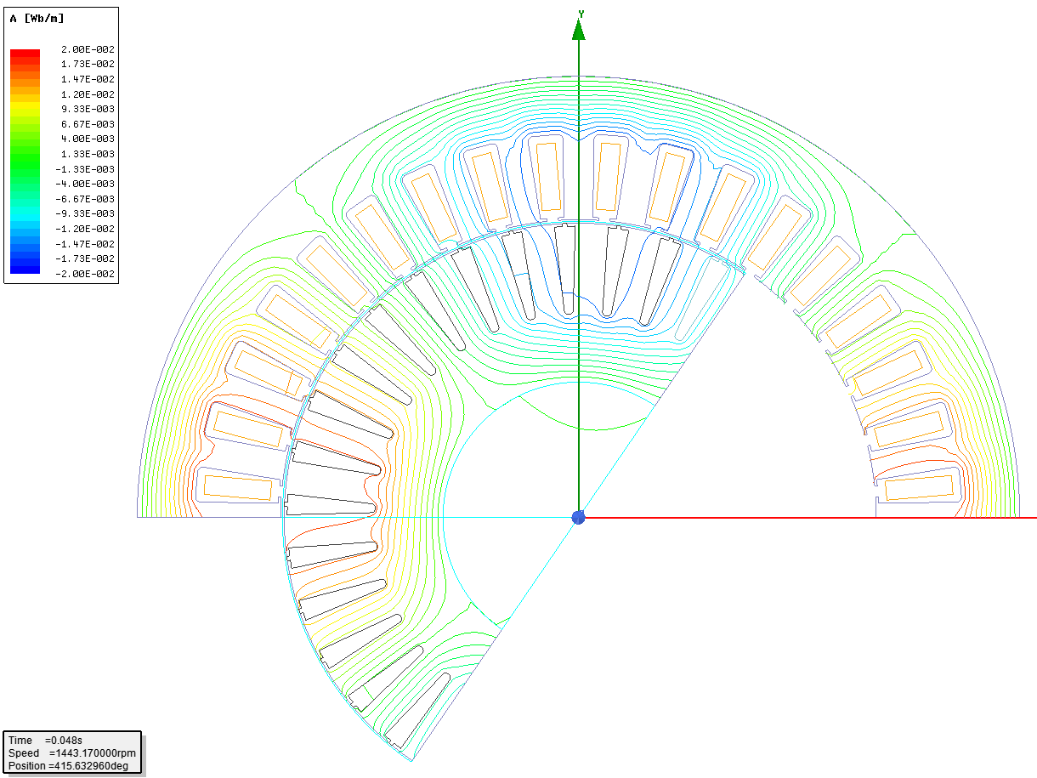

Figure 3: Flux lines

As can be seen in previous figure, flux per pole is divided into two in stator yoke. Maximum flux density at yoke is caused by half of the flux per pole. Considering this, stator yoke height can be calculated using following equations.

Where is magnetic loading and is the peak flux density at stator yoke.

## Stator Winding Design

In this section, stator turns number, winding factors, and wire selection will be studied. In the machine, **single layer, integral slot, full pitched, distributed winding** will be employed. There are 48 slots in the stator and there are 2 slots per pole per phase. Stator winding diagram for the design can be seen in following figure.

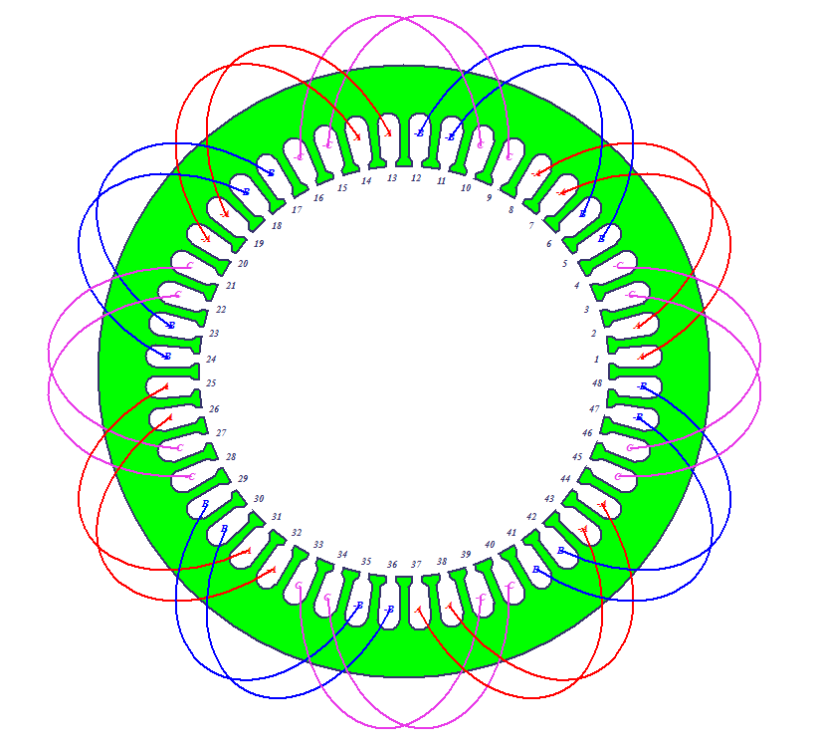

Figure 4: Stator winding diagram

With this configuration, let’s calculate winding factor for fundamental and some harmonics.

Where is harmonics, is number of slots per pole per phase, which is 2, and α is the slot angle in electrical degrees. It is calculated as follows.

Using pitch factor and distribution factor, winding factor is calculated as follows. Also, winding factor for some harmonics are listed in following table.

Table 2: Winding factor for some harmonics

|  |  |  |  |
| --- | --- | --- | --- |
|  | kp | kd | kw |
| Fundamental | 1 | 0.9659 | 0.9659 |
| 3rd | -1 | 0.7071 | -0.7071 |
| 5th | 1 | 0.2588 | 0.2588 |
| 7th | -1 | -0.2588 | 0.2588 |
| 9th | 1 | -0.7071 | -0.7071 |
| 11th | -1 | -0.9659 | 0.9659 |

Note that even harmonics does not exist because they have zero pitch factor. Here, since we will have Y connection, triplen harmonics will be eliminated automatically. Let’s focus on 11th harmonic. Although, higher order harmonics such as this have large winding factor, since air gap flux density for that harmonic is very small, they have no effect on THD and other kind of effects.

Now, let’s focus on stator winding and number of turns. In order to calculate number of turns per phase, we can use induced voltage relation.

Where is the induced phase voltage, which is 230 V, is the number of series turns per phase, is the supply frequency, is the fundamental winding factor, which is 0.9659, and is the peak flux per pole. Using this, number of turns per phase can be calculated easily.

Number of conductors in a stator slot is calculated as follows.

This number is very small. Probably wire cross section area will be very large and we will use stranded wire for easy production. In that case, we will use paralleled stator windings. In order to see this, let’s calculate stator current.

Where is the apparent power calculated with initial assumptions of efficiency, , of 0.95 and power factor, of 0.84. At the final design, power factor and efficiency should be close to these assumptions. Then, using apparent power, stator input current can be calculated easily.

Where is the current density, which is fixed at 6 A/mm2. With the stator current of 452 A, we needed a wire of 75 mm2, which is very large. Therefore, as predicted, we will use **parallel connection** of stator windings.

Let’s use a standard wire. **AWG 12 wire** can be a solution, which as diameter of 1.45 mm and cross section of 1.65 mm2. With this choice, we will have **46 parallel connected AWG 12 wires for one conductor and 4 conductors per slot.**

Parallel connection has some advantages. First of all, parallel connection provides manufacturability. We prefer to use stranded thin wires instead of a bulky thick wire. Also, by stranding wires, we decrease eddy current losses. Skin depth increases the losses for thick wires. Additionally, paralleled wires decrease the resistance and provides better thermal design.

Lastly, in this section we will determine slot depth. Since we decided number of turns and we know slot width, we can determine slot depth by assigning a suitable fill factor. Fill factor is defined as ratio of areas of conductors in a slot to slot area. It is suitable to have **0.5 fill factor** considering manufacturability. Therefore, slot depth can be calculated as follows.

Where is number of AVG 12 wires in a slot, is AWG 12 wire cross section area, and are slot depth and width respectively. They are defined in Figure 2. Using equations, we get slot depth of 39 mm. With this result, we concluded stator dimensioning and wire configuration.

## Resistance and Efficiency

In this part, phase resistance and overall efficiency of the motor is calculated. In order to find resistance of one phase, let’s consider one turn length. It will consist of twice of axial length and twice of end windings. End windings length is approximately equal to pole pitch since we have full pitched windings. Then one turn length is calculated as follows.

Where is axial length of the motor. For one turn of conductor, we have 46 wires. Therefore, in order to calculate one turn resistance, we should find resistance of one AWG wire and divide it to 46. While calculating this, assuming operation **temperature of motor is 75 deg**, resistivity of copper is .

Where is resistance of one turn AWG 12 wire and is resistance of one turn conductor. Remembering that number of series turns per phase is 32, we get phase resistance as follows.

Using calculated phase resistance, stator ohmic losses can be calculated easily.

Now, we can calculate efficiency of the motor. However, we find other losses of the motor such as friction and windage losses, core losses and rotor ohmic losses. Core losses are caused by magnetic material in rotor and stator. Changing magnetic field on a magnetic and conducting material induces some voltage and causes circulating small currents on it. This causes losses and decreases efficiency. In order to prevent this, we make stator and rotor core as laminated. We also have some mechanical losses. All losses considered in efficiency calculation are summarized below.

Table 3: Losses in the design

|  |  |
| --- | --- |
| Loss source | Value |
| Stator ohmic | 6.1 kW |
| Friction windage | 2 kW |
| Stray losses | 2.5 kW |
| Core losses | 1 kW |
| Rotor ohmic losses | 3 kW |
| Total losses | 14.6 kW |

Using above calculated and assumed losses, efficiency can be calculated as follows.

Note that this efficiency value can be higher with further optimized design. Loss of 14.6 kW can cause thermal problems. In order to cool down machine efficiently, some methods can be used. For example, a fan can be placed on the shaft of the motor. This air cooling can increase the efficiency of the machine by decreasing motor temperature. Alternatively, some cooling ducts can be placed between stator laminations. This can also decrease motor temperature. Furthermore, liquid cooling methods can be preferred but for a wind turbine generator, this can be unnecessary.

## Mass Calculations

In the design, we have three different parts to consider while calculating machine overall mass. They are stator mass, rotor mass, and copper mass. Let’s first start with stator and rotor mass. We know density of steel and we need to calculate approximate volumes.

Here, rotor and stator inner and outer dimensions are calculated from the results obtained at previous parts. Lastly, let’s calculate copper mass.

Where is number of wires per conductor, which is 46. Then, copper mass can be calculated using copper density.

# Finite Element Analysis

After creating our design analytically, now, we can verify design parameters in a finite element software. In order to do this, we will use RMxprt tool of Ansys Maxwell. In this platform, we will model our design and observe the results and compare them.

## Performance Curves

Using RMxprt tool of the Maxwell finite element analysis software, designed asynchronous machine is modeled with above sizes. After analyzing model in Maxwell, following results are obtained.

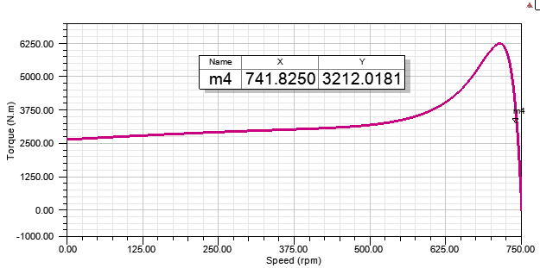

Figure 5: Torque speed characteristics

According to analysis results, designed machine works at 742 rpm, which is rated speed. At this speed, it is seen that rated torque is produced as shown above.

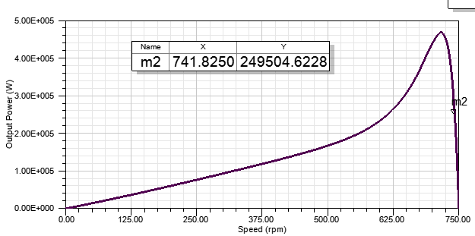

Figure 6: Output power vs speed characteristics

As can be seen above figure, rated power, 250 kW is achieved at rated speed, as expected.

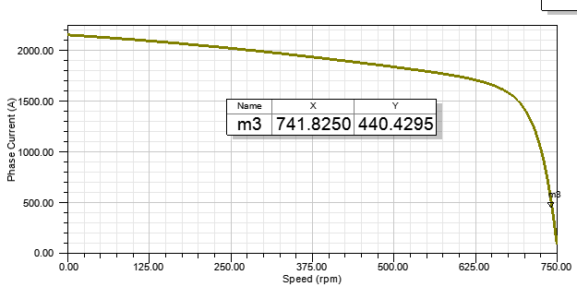

Figure 7: Phase current vs speed characteristics

In analytical design, we calculated phase current as 452 A, we get 440 A at RMxprt, which is acceptable.

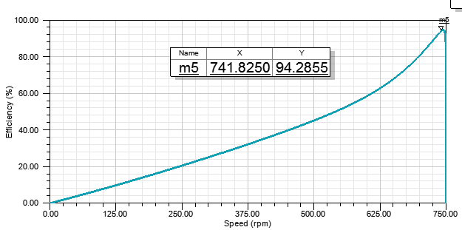

Figure 8: Efficiency vs speed characteristics

## Performance Data

Table 4: Magnetic data obtained from RMxprt

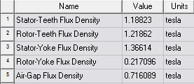

As can be seen air gap flux density value is 0.72 T. But this is peak value, not average. Average value corresponds to 0.46 T. Analytically, it is 0.5 T. Also, note that peak flux density in the stator yoke is 1.2 T. In analytical calculations, we desired stator yoke and tooth flux density to be 1.5 T, but in RMxprt, we get less values. I guess this is caused by leakage fluxes. Analytically, we assume all flux is passing through stator tooth. In simulation, there are some leakage fluxes, which is not passing through stator tooth and yoke. This effect caused less flux density in simulation compared to what we desire. But this difference is about 12 %, which is acceptable considering leakage fluxes.

A small note, I used magnetic shaft, therefore, we see very small magnetic field density in the rotor.

Table 5: Electrical data obtained from RMxprt

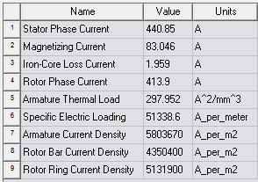

Here, we observe that electrical loading is 51 kA/m, which is close to 49 kA/m, analytical electrical loading. Also, phase current is 440 A. Note that current densities are in safe region.

Table 6: Rated performance of the design obtained from RMxprt

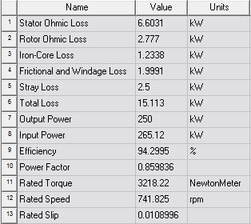

Here, in rated performance, we see that speed, torque and power values are as we desired. Motor can work at desired operation points. Our loss calculations are accurate enough. Stator ohmic losses are calculated as 6.1 kW and found 6.6 kW in Maxwell. This difference can be decreased with more detailed analytical design.

Table 7: Material consumption of the design obtained from RMxprt

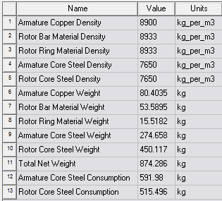

According to results, total motor weight is 874 kg, which is close to our analytical result, which is 831 kg.

Table 8: Rated parameters of the design obtained from RMxprt

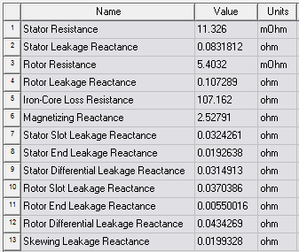

Here, stator resistance calculation is very close to analytical one. All analtyical and RMxprt results are listed and compared in Table 9.

## Current and Voltage Waveforms

2D design of induction machine is created using RMxprt tool and current and voltage waveforms are achieved at steady-state operation.

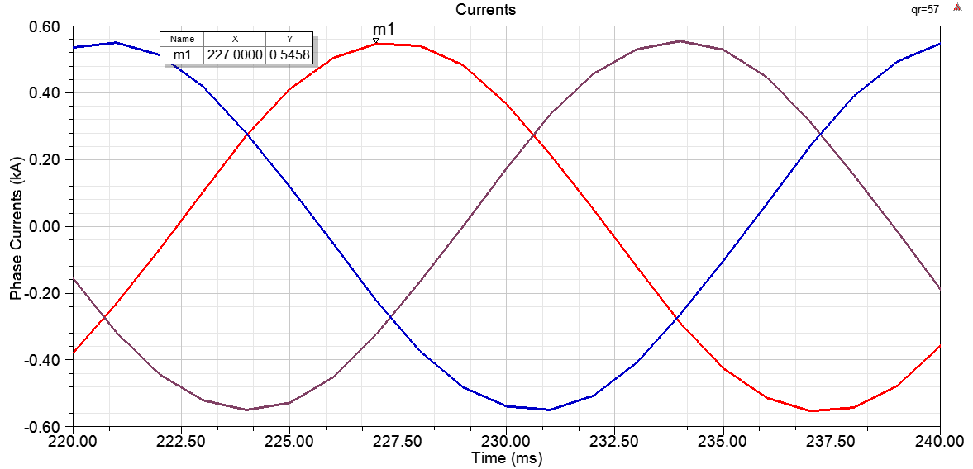

Figure 9: Phase currents

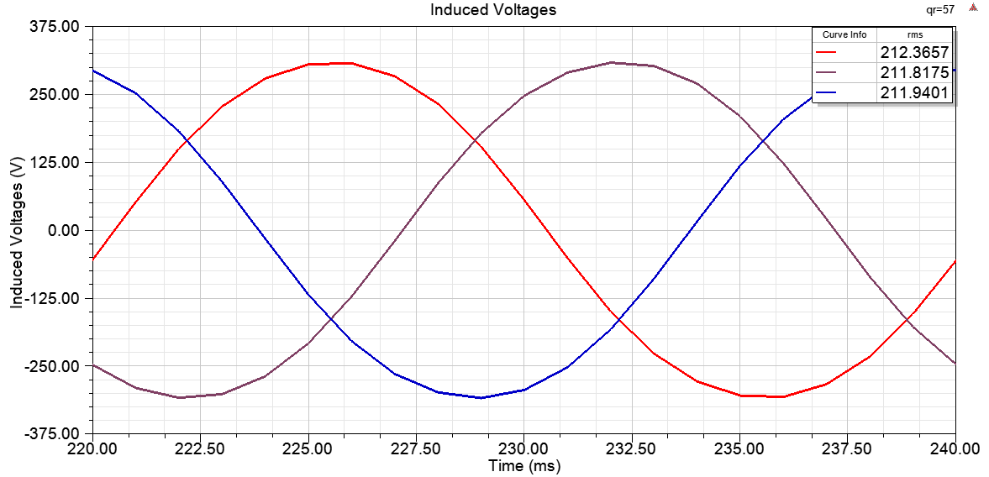

Figure 10: Induced voltages

Here, analytically we assumed that induced voltage is equal to phase voltage, which is 230 Vrms. However, it is observed that induced voltage is around 210 Vrms. This is due to voltage drop on stator resistance and leakage reactance. Since these impedance is small, at rated operation, we neglected voltage drop on them and proceed.

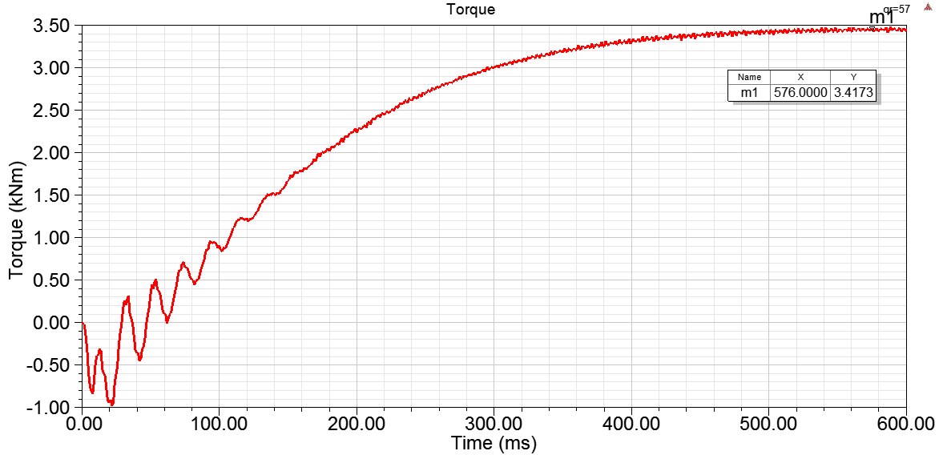

Figure 11: Induced voltages

Here, at start-up, we observe torque ripple. Since rotor initial speed is zero, until currents are increases, negative torque is produced. After 400 ms, torque is reached steady state. At steady state, torque is 3417 Nm, which is a bit higher than rated torque, 3217 Nm. I guess this is caused from induced voltage. We assumed induced voltage should be 230 V and ignored stator resistance. Due to this induced voltage become smaller and to provide same output power, larger current is drawn from grid as shown in Figure 9. Thus, larger torque is produced in steady state.

## Flux Density Distribution

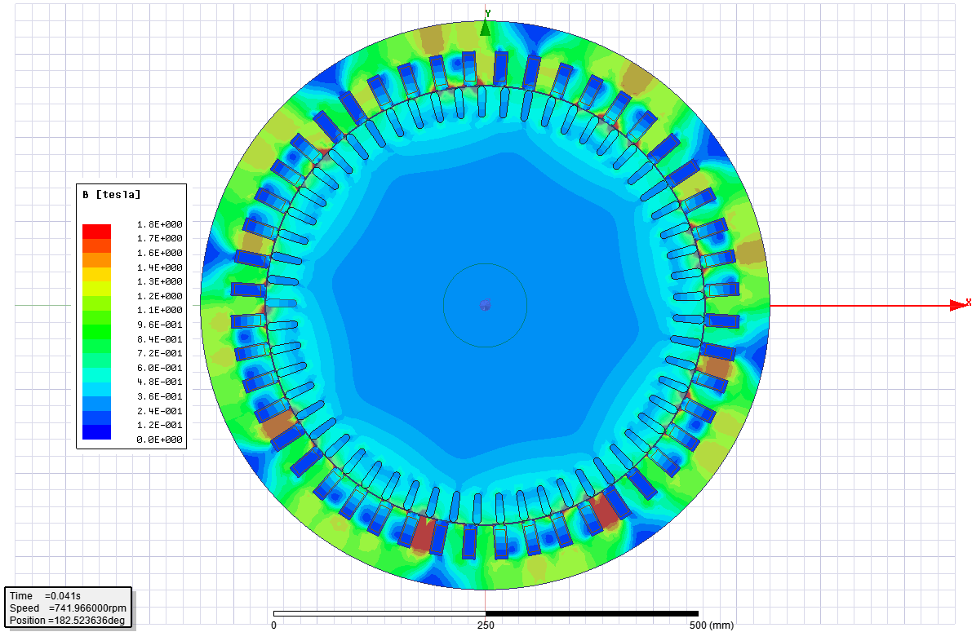

Figure 12: Flux density distribution

As can be seen in the flux distribution, flux density reaches 1.3-1.4 T at the stator yoke. Our selected core material, steel, saturates at 1.7 T and therefore, core is not saturated. At some instances, some of the teeth can be saturated as shown above.

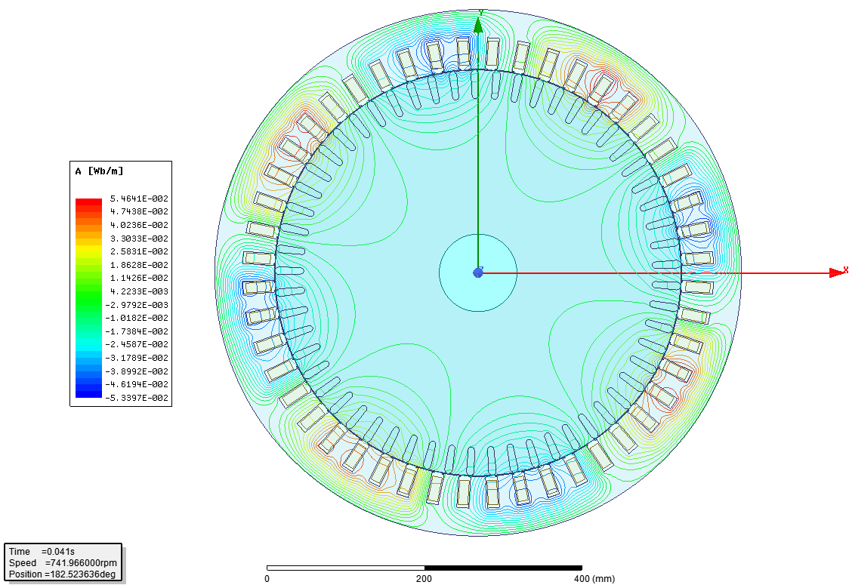

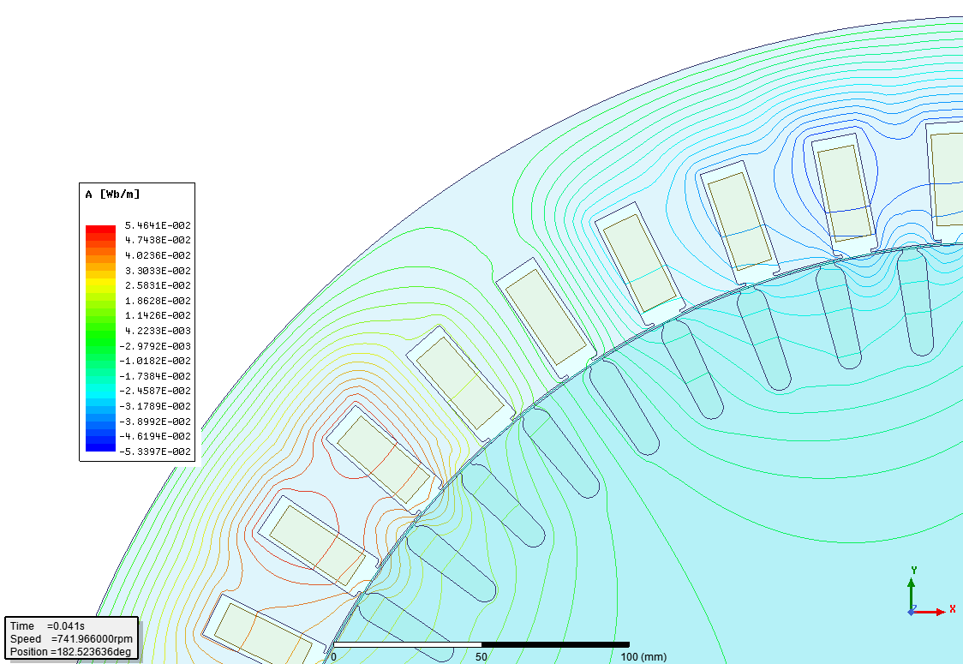

Figure 13: Flux lines

Here, we can see number of poles of our machine, which is 8. Also, leakage flux lines passing through slot openings can be seen in the above figure.

## Effect of Rotor Slot Number

In the design, we determined stator slot number as 48. There is no exact equation to find rotor slot numbers; but there are some points to consider. First of all, rotor slot number should not be multiples of stator slot number. This can introduce extra harmonics and cogging torque. Additionally, following combinations should be avoided for the same reasons;

In our design, **rotor number of slots are chosen as 57**, which is not violating above cases. With this selection output torque is achieved as follows. Also, let’s observe the torque characteristics with slot number of 56, which is violating above consideration.



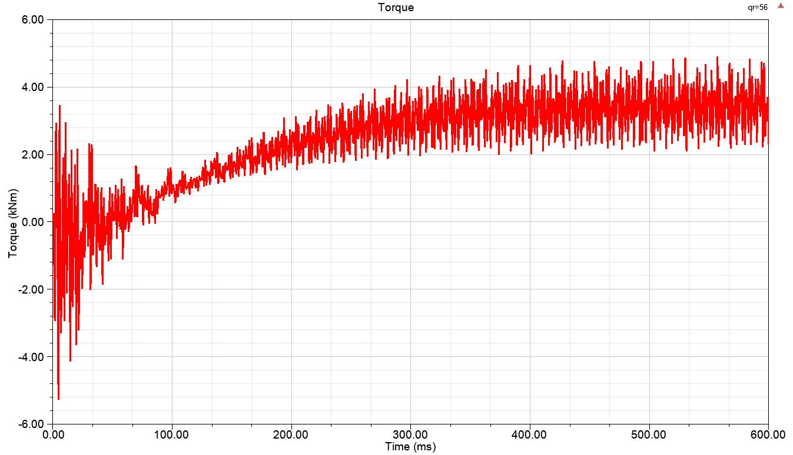

Figure 14: Choice of rotor number of slots, 57 and 56 respectively

With the second choice, number of rotor slots is pole number more than stator slot number. This situation introduced cogging torque and introduced harmonics in the motor. As a result, we get a torque characteristic with large ripple. Therefore, rotor number of slots should be selected carefully and our choice, which is 57 had good results.

## Comparison of Analytical and RMxpt Results

Table 9: Comparison of analytical and RMxprt results

|  |  |  |
| --- | --- | --- |
|  | Analytical | RMxprt |
| Rated power | 250 kW | 250 kW |
| Rated speed | 742.0 rpm | 741.8 rpm |
| Rated torque | 3217 Nm | 3218 Nm |
| Phase current | 452 Arms | 441 Arms |
| Efficiency | 94.5 % | 94.3 % |
| Electrical loading | 51 kA/m | 49 kA/m |
| Magnetic loading | 0.50 T | 0.46 T |
| Stator yoke flux density | 1.5 T | 1.37 T |
| Electrical loading | 49 kA/m | 51 kA/m |
| Stator copper loss | 6.1 kW | 6.6 kW |
| Power factor | 0.85 | 0.86 |
| Stator resistance | 9.9 mΩ | 11.3 mΩ |
| Magnetizing reactance | 2.2 Ω | 2.5 Ω |
| Mass | 831 kg | 874 kg |

In the results, rated parameters such as power, torque speed has good dependence between analytical and FEM results. Losses and mass are also accurate enough. Only magnetic electrical loading has deviation of 5-8 %. In the FEM, we have a bit larger electrical loading and a bit smaller magnetic loading. I guess, this small difference is caused by leakage inductances, which is not modeled in analytical design. These losses caused less flux density in the FEM and thus caused larger electrical loading to provide output power. In overall, results are accurate enough.

# Conclusion

In this report, an induction generator for wind turbine application is designed with 250 kW power rating. First of all, an analytical design is achieved with pen and paper. During analytical design, we started with choosing electrical and magnetic loading. Also, defining aspect ratio, we get main dimensions of the machine using torque and stress relation. It is observed that machine volume is not proportional with power, but torque. After determining main dimensions such as bore diameter and axial length, stator winding configuration is analyzed. A full-pitched, single layer, distributed winding arrangement is achieved. Then, stator number of slots is decided using induced voltage relation. Due to practical considerations, parallel turns are added to the stator winding in order to decrease wire diameter. This also allowed to have higher efficiency by decreasing eddy current losses. Also, better design is achieved in terms of thermal considerations. Next, we decided stator slot dimensions and stator yoke dimensions by considering fill factor and stator core saturation, respectively. In rotor side, since we had shorted aluminum bars, the only design consideration was rotor number of slots. In order to achieve light-harmonic and smooth design, some combinations between rotor and stator number of slots should be avoided. Wrong selection may cause cogging torque, harmonics, and also noise.

Analytical results are verified with finite element analysis. Good consistency is achieved with analytical and finite element results. In analytical model, leakage inductances are not modeled. This led us to have less magnetic loading in finite element analysis than we expected as analytically. This also lead us to get a bit higher electrical loading. This difference is about 5-8 % only.

In overall, this study and lecture was teaching and I believe we learnt basic principles of electrical machines design.